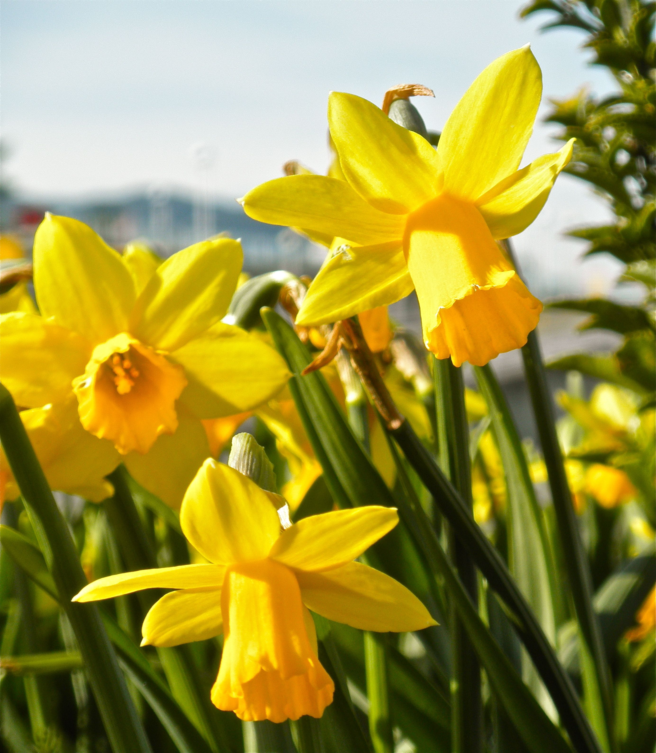
March 31
A typical west coast spring: rain, sunshine, hail, rain, sunshine. All on the same day. This morning, I sat at the kitchen table, drinking a cup of coffee and reading a newspaper full of bad reports about the spreading coronavirus. Outside the window, low dark clouds rushed northeast, pushed by the wind. Higher up, behind them, lighter grey clouds swirled, changing shape as they moved northeast. And behind them all, shapeless clouds drifted along slowly.
I was in the same sort of mixed mood today. Reading all the emails from you this morning was a delight. Learning tricks for using Google Classroom from Mr. Honey this afternoon was amazing. Coming home with bags full of fresh produce from produce was a joy. Shiny red tomatoes. Bright sweet-smelling oranges. Fresh green beans. Everything was wonderful.
But then I had to wash all that produce. Make sure there were no viruses on it. Pile it in a sink full of soapy water, wash and rinse it, and spread it all on tea towels to dry. After I’d finished washing the second sinkful of vegetables, I was starting to feel grumpy.
Went for a walk around Mill Lake with a friend. Enjoyable even though we had to walk three feet apart. (I know we’re told to walk six feet apart, but who can have a proper conversation like that?) It’s entirely too much, all these precautions to prevent catching Covid-19. But what are the alternatives? Nothing good.
Came home. Grumpiness returned. Several hours of school work yet to do. Read journal entries. Plan tomorrow’s lessons. Write this journal entry. Harrumph.
But once I read your responses, I felt more cheerful. You, too, I can see are full of frustrations. This is a difficult time for us all. And what is worse, we have no good reason to be grumpy. We are – so far – healthy. We have homes in which to live. We have food to eat and friends to call and people to love. Even though everything feels different now, our situation will not last forever.
So now, I am listening to pleasant music on my fabulous Bose speaker and remembering the incongruous call of an eagle I saw in a tall cottonwood tree by the lake. You’d think that a majestic eagle would have an equally impressive voice. But it’s call sounds like an annoyed cat or a cranky baby. It’s so high-pitched, so human, that even the memory of it makes me smile. Laugh. Life is peculiar. So many surprises.
And my surprise, this year, is you! You’re a wonderful group of students, always working hard to learn more and more about reading and writing and math. About life. Thank you. We’ll get through this stormy time together.

